**Project 2 Part 1**

Name: _____________Michael Fatemi_______________

Date: _____________10/11/2020___________

Is your lab name l021?(lowercase L followed by digits 021) _____Yes______

Did you use the precision for the points like in the sample? _____Yes______

Did you test your file on a school computer using ssh? _____Yes______

Did your file compile and run on school computer? _____Yes______

Paste here **2 clear picture/content** of the points.txt you created when running 2 times your lab:

(0.12673727941081733,0.88993110036939904) , (0.37776209524728455,0.43796056250015297) , (0.73023746150091173,0.01430869522239486) , (0.84294517004999570,0.88397534139639478)

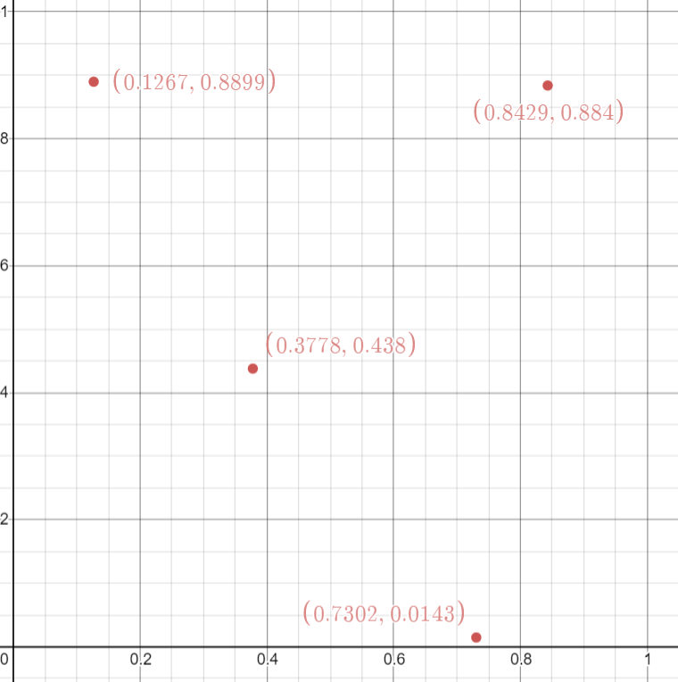

(0.49613940855128635,0.14517654957731865) , (0.75460066530350656,0.19363994262520218) , (0.76342051454206972,0.82647175511948001) , (0.52113406781212801,0.68364513077181310)

